Browser Settings for PandA
The PandA website for Production is https://fabear.fin.ucar.edu/Prod
Login with your CIT login/password.
PandA User Guide is at http://pandahelp.ucar.edu
Internet Explorer: In IE, the PandA website should be in the Local Intranet zone and that zone should be set to automatically login. You may need Administrative rights to change settings or a sysadmin’s help if they are set automatically by group policy.
The settings are in Tools, Internet Options, Security. Select Local Intranet and Sites, Advanced to add a site. Add the specific website or *.fanda.ucar.edu (as shown below) if it’s not already listed; OK, OK to save and exit.
To set it to automatically login, select Local Intranet and the Custom Level button. Scroll to the bottom under User Authentication and make sure “Automatic logon only in Intranet zone” is selected. OK and restart IE or clear temporary internet files and refresh.
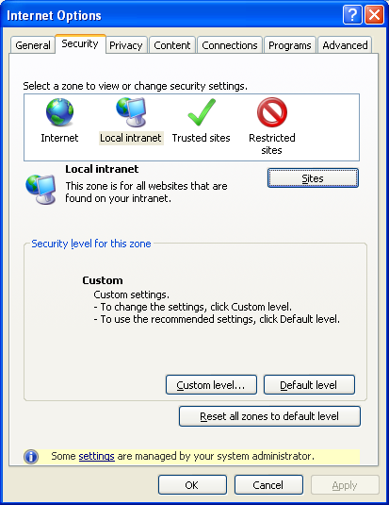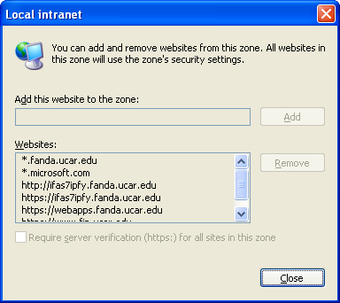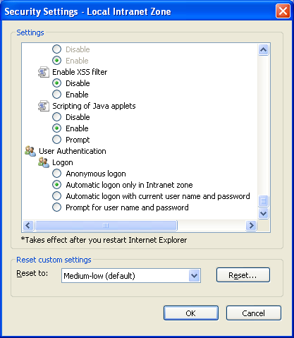
Firefox: In Firefox, you need to add the CPM servers as trusted. This setting is necessary for creating and exporting Budget Reports in PandA; if it is not set, you will be prompted for a login when you create a Budget Report but it might not work (CIT account could be disabled, expired or don’t know the password).
Type about:config in the URL line and scroll down to the network.automatic-ntlm-auth.trusted-uris line.
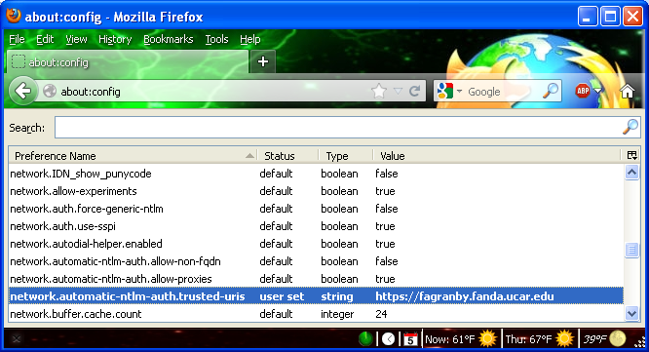
Double-click on it to display the Value and type in https://famead.fin.ucar.edu,https://fagranby.fin.ucar.edu, for production as well as testing. Choose OK to save.
Attachments: When uploading attachments, you may get up to 3 pop-ups with security warnings when you click on “Add”. Note that the upload process uses Java, so if the Java plug-in in your Firefox is disabled by policy, you have to use IE for PandA.
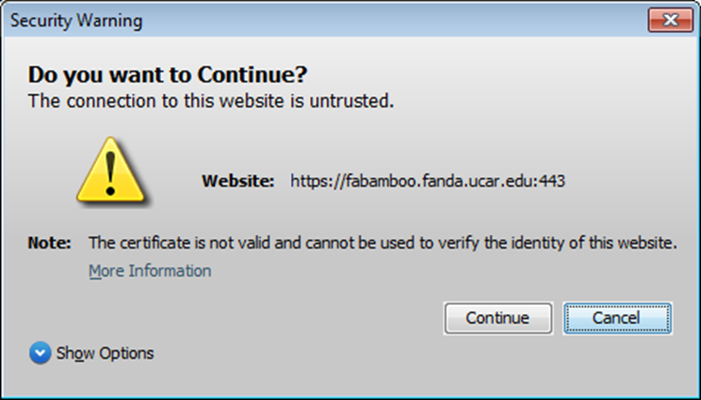
Choose “Continue” to get past this warning. To prevent it, add the website to Local Intranet Sites as instructed above.
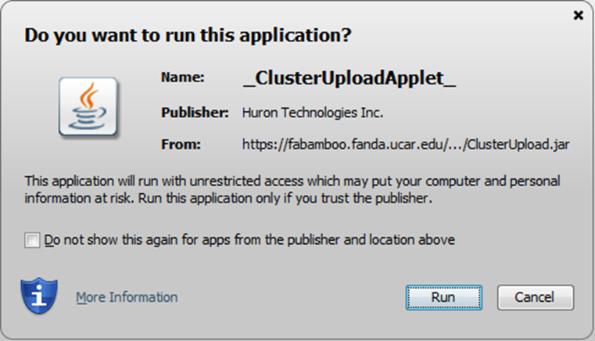

Check on “Do not show this again…” to prevent this pop-up from coming up again. Choose Run to continue.
Once you’ve added the document and click “OK” there might be a 3rd pop-up, and it might be hidden behind your open app windows. If the document doesn’t process, look for the following pop-up – you might need to minimize your other programs to see it:
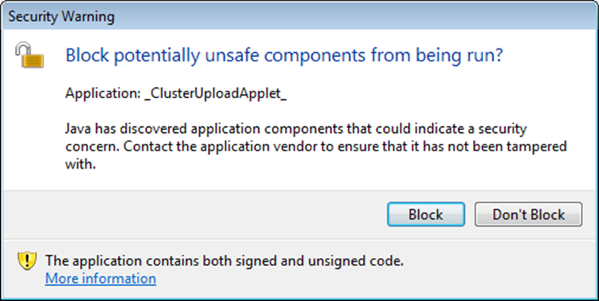
Choose “Don’t Block”, which is not the default; the attachment will now appear.
To prevent this one from coming up, go to your Java security settings (Control Panel, Java, Advanced tab).
Under “Mixed Code (sandboxed vs. trusted) security verification:
Default is “Enable – show warning if needed.” Change it to “Enable – hide warning and run with protection.”

